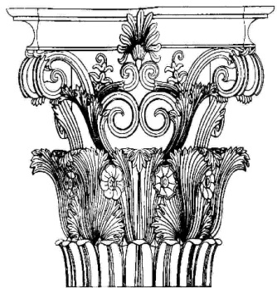

Indiana Masonic Home Foundation
Corinthian Society
Letter of Intent

As an expression of our commitment to the Indiana Masonic Home at Compass Park and the Principles of Freemasonry, I/we:

intend to support the Indiana Masonic Home Foundation by naming the Foundation as beneficiary in our estate plan, insurance policies, or other estate-planning instruments in the approximate amount of: $______________ or _____% of said estate (estimated present value of gift: $_____________). The proceeds will be used:

____ for support of the permanent endowment fund; or

____ to fund the _________________________________________________
Name of Specific Project

This Letter of Intent is an expression of our present plans, which are subject to modification by us, and are not legally binding on our estate.

While we understand that the amount of our gift will not be publicized without our permission, the Indiana Masonic Home Foundation may publish our names among those of other Corinthian Society members in the Indiana Freemason and Foundation publications, including the Foundation’s website.
□ We prefer not to be publicly recognized for our commitment.

___________________________________
Signature Date
___________________________________
Signature Date

Birth Month/Day: ______/______ Birth Month/Day: ______/______
Address: ____________________________________
____________________________________
Phone: ____________________________________
Email: ____________________________________

__________________________________
Jeffery P. Zaring Date
Executive Director

Mail Letter of Intent to:
Indiana Masonic Home Foundation
P.O. Box 44210
Indianapolis, IN 46244-0210

